1. Download Android Studio form the internet.  
   <https://developer.android.com/studio?gclid=Cj0KCQjw9_mDBhCGARIsAN3PaFNBafNjn3msBoiPEXrUtSz0T_pKhQdOZoowy0aOJtreiDIu65ggyAMaAhTWEALw_wcB&gclsrc=aw.ds#downloads>
2. Download the zip file from the fyp system.
3. Extract the zip file.
4. Open the extracted folder in Android Studio.

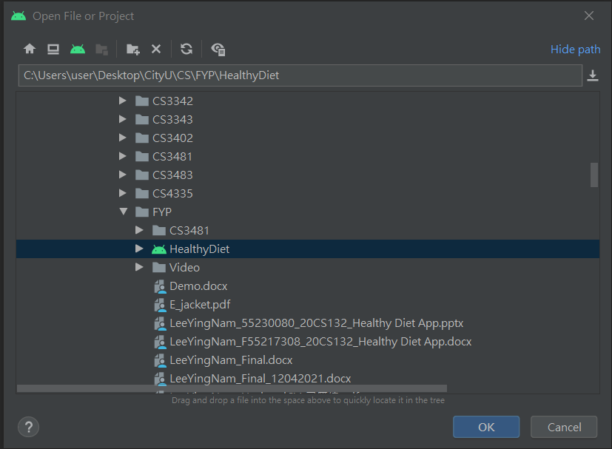

1. Wait for the project to build



1. Plug your Android phone into the computer, the Android Studio will automatically recognize your phone.



1. Run the project on your phone by clicking the run.

